BIO 103 Review Questions for Exam #2 - Fall, 2017 Chapters 7, 8, 9 and 10.

Chapter 7
1) How do the structure and function of prokaryotic cell flagella differ from those of eukaryotic cells?

2) Define: nucleolus, endomembrane system, lysosomes, autophagy, apoptosis, phagocytosis, contractile vacuoles, plastids

3) What is the role of the central vacuole in plant cells?

4) Mitochondria show maternal inheritance. What does this mean? Be prepared to sketch and properly label the general structure of both mitochondria and chloroplasts.

5) What makes rough endoplasmic reticulum rough? What are some of the functional differences between smooth and rough endoplasmic reticulum? Describe how ribosomes work with the rough ER to produce membrane bound proteins. How do those ribosomes know to specifically target the ER for the production of these proteins?

6) What is the general role of motor proteins in a cell? Can you provide examples of these proteins?

7) The number and size of organelles in a cell correlates with that cells function. What might you expect the function to be for a cell that has an extensive amount of rough endoplasmic reticulum? Or, one that has numerous plastids filled with starch?

8) Compare and contrast the structure and internal components of a generalized plant cell, animal cell and prokaryotic cell. Which features are common to all cells? Which are specific to just prokaryotes, or just plants, or just animals? What is the functional role of the major eukaryotic organelles discussed in class? (Endoplasmic reticulum, Golgi apparatus, lysosomes, mitochondria, chloroplasts, etc.). Table 7.2 in the textbook is a good summary of this information.

9) What are some of the antibiotic targets in bacteria that were discussed in class? Why are those specific structures good targets for antibiotic compounds?

10) Cells tend to be small because of a problem involving the ratio of surface area to volume. What is the problem? Why can’t a single cell be the size of a basketball?

11) Why do plants need both chloroplasts and mitochondria? What is the evidence that these two organelles were derived as a result of endosymbiosis? Which endosymbiotic relationship arose first? How can we tell?

Chapter 8
12) What are Plasmodesmata? Where are they found? Desmosomes? Gap Junction? Tight Junction?

13) Steroids have the ability to pass through the cell membrane and into the cytosol. How is this possible? What is their subsequent path to achieve an impact on the function of the cell?

14) In general, what is a signal transduction pathway, and how can it amplify the message that’s being sent to a cell?

15) In cellular communication, what are the impacts of paracrine, endocrine and synaptic signaling? How does each function?

16) What is the difference between a hormone and a pheromone?

17) Describe the molecular/membrane basis of selective adhesion in animal cells.

18) How do the class of medications known as beta-blockers work at the cell membrane to lower blood pressure?

19) Define: extracellular matrix, cellulose, collagen, phosphorylation cascade

20) What are the four steps in a signal transduction pathway? How do G-proteins work? How do enzyme-linked receptors work?

Chapter 9
21) Where in the eukaryotic cell does glycolysis occur? What molecules are produced from the carbon atoms in glucose as a result of glycolysis? What is the net production of ATP during glycolysis?

22) How are exothermic reactions coupled to endothermic reactions in order to drive cell processes?

23) How is glycolysis affected by the absence of oxygen?

24) What does it mean when an athlete has an “oxygen debt” and how is this “debt” repaid?

25) Where in a eukaryotic cell do the oxidation of pyruvate, the citric acid cycle and the passage of electrons along the electron transport chain occur?

26) During glycolysis, how is phosphofructokinase (PFK - the third step in the pathway) involved in pathway regulation? Why is it a good point of regulation (as opposed to other enzymes) along the pathway?

27) During respiration, the role of the electron transport chain is largely to pump protons from one side of a membrane to another. What does it accomplish by doing this?

28) What is ATP Synthase? How is an electrochemical gradient involved in its function?

29) Be able to sketch and/or label the major components of a mitochondria and chloroplast.

30) What is energetic coupling and how is it involved in driving endergonic reactions during respiration?

31) In what ways does fermentation differ from cellular respiration?

32) What are the three stages of cellular respiration and what does each accomplish (glycolysis, citric acid cycle and oxidative phosphorylation)

Chapter 10

33) Why do plant cells prefer to be in a hypertonic condition?

34) What is the role of the central vacuole in plant cells?

35) Know the details of this… 6CO₂ + 12H₂O + light energy → C₆H₁₂O₆ + 6O₂ + 6H₂O

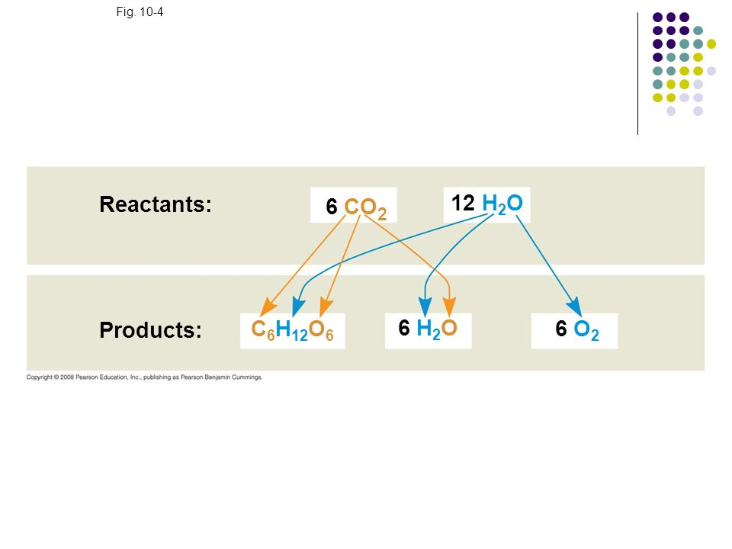

36) Know and be able to identify the parts of a chloroplast:

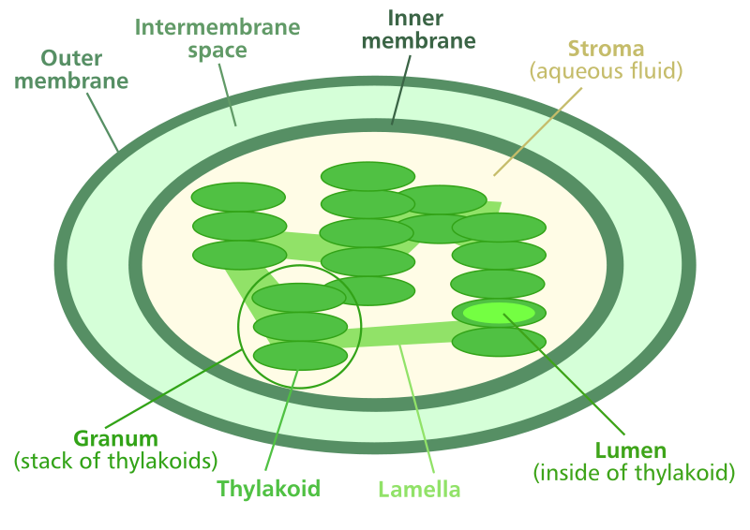

37) Which wavelengths of the visible light spectrum are most energetic? Which are least energetic?

38) What is the basis for fluorescence that is exhibited by many chemical compounds (including the process that takes place in fluorescent light bulbs)? How does this relate to the behavior of chlorophyll in plants?

39) What is an absorption spectrum? Why is chlorophyll green?

40) Be able to fill in the blanks of this diagram:

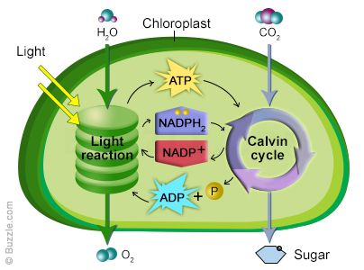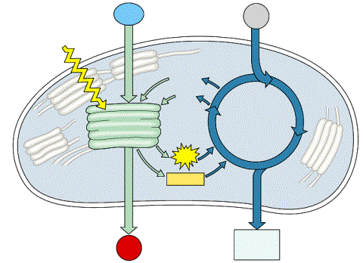

41) What do the light-dependent reactions of photosynthesis produce?

42) Why is photosystem I in photosynthesis considered cyclic?

43) What is the source of electrons to the non-cyclic photophosphorylation pathway?

44) What are accessory pigments? Why do leaves turn colors in the fall?

45) What is the overall, balanced equation for photosynthesis? Where do the oxygen atoms in the O₂ produced come from?

46) Describe the difference between the light dependent and light-independent reactions in photosynthesis.

47) Describe the Calvin cycle in photosynthesis.

48) What is photorespiration? What advantage do C₄ plants have over C₃ plants with respect to photorespiration?

49) What does it mean to say that CO₂ has become fixed during photosynthesis?

50) How does a spectrophotometer work?

Define: accessory pigments, stroma, thylakoids, stomata, extracellular matrix, rubisco, autotroph, heterotroph, carnivore,

